OPAL Guide

(Part 1- The Basics- Building your portfolio)

Occupational Therapy Students

Placement Preparation



Introduction to OPAL
OPAL is the Online Practice Assessment for Learning system that is used at BU across all Health Care courses. It is a custom built system that can be accessed on any computer, tablet device or smart phone linked to the internet. It is your practice portfolio which has been designed to support your learning in practice and record that you have met the required intended learning outcomes and competencies that demonstrate that you have met the HCPC Standards of Proficiency for Occupational Therapists (2013) so that you may be eligible to register with the HCPC after successful completion of practice and academic elements of the programme.
The portfolio will record all your practice learning experiences, in a chronological order and anyone linked to your portfolio will be able to see previous placements.
Your portfolio is ‘student led’. This means that you will need to complete sections for your Practice Educator so they can access different elements. You should think of your practice assessment as an assignment with your Practice Educators as the unit lecturers.
Please take time to familiarise yourself with this useful tool and complete the first basic steps. Further resources will be available prior to the start of your next placement. We hope the below will help you navigate the system.

How to Access OPAL
- Go to www.opalbu.com
- Use your log in details (these were sent to you by the placement team)
- You should see this message, click ‘start your course’
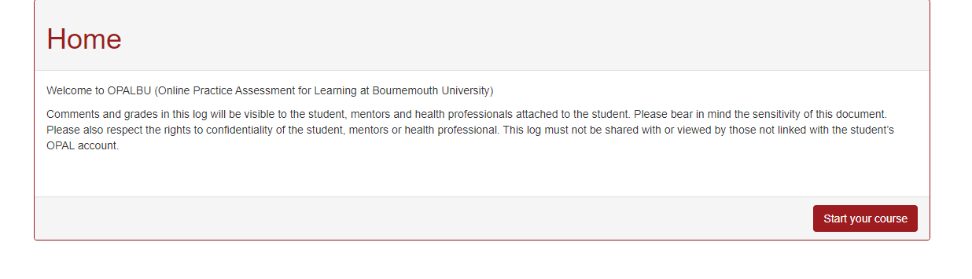

Getting started
On the home page you should be directed to start your course, click here, select your course and the start date of your programme for OT it should read September and the year you commenced your studies i.e., 2020 and then click save.

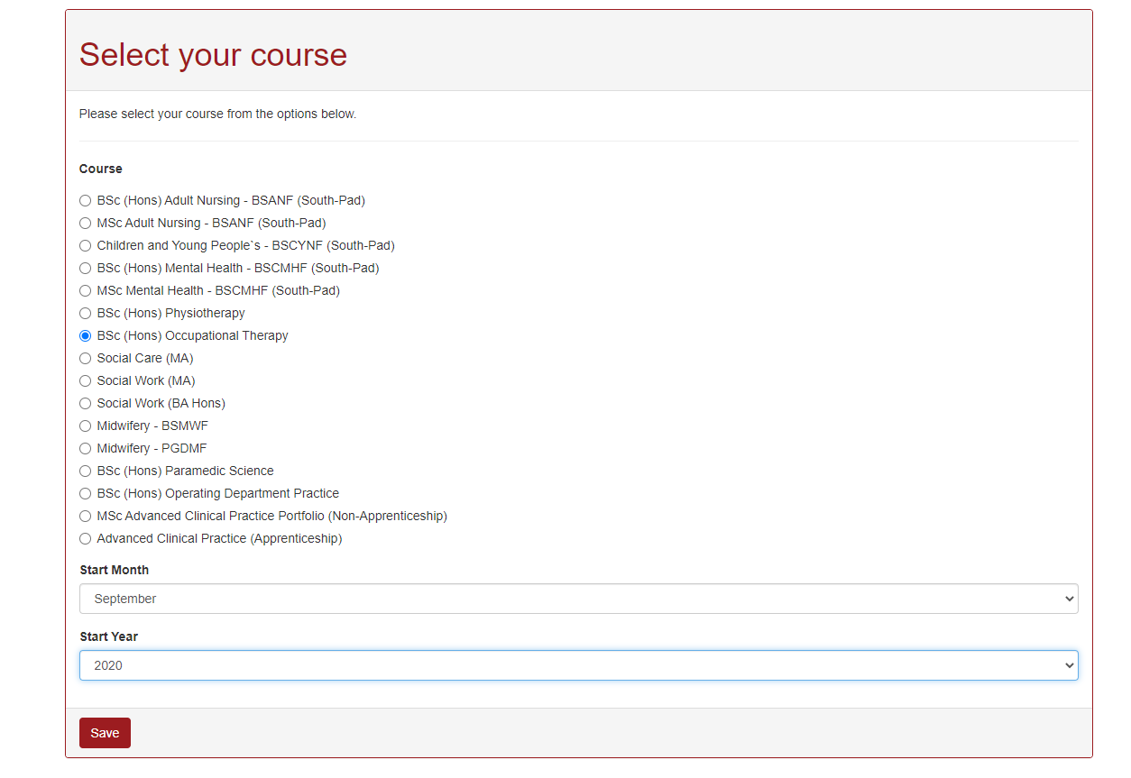
You will then be directed to a page on the programme, your attendance, professional issues and responsibilities. Please read this and tick the box to accept the terms and conditions. Click the save button.

Linking your academic advisor
Your academic advisor (AA) is responsible for supporting you during your practice placement experience. They will offer support to help you celebrate your successes and navigate any challenges you might have. Your AA will contact you and your Practice Educator (PE) at the halfway point in the placement to offer support and advice to help you meet your intended learning outcomes.
It is your responsibility to link your AA to your portfolio so they can monitor your progress and sign off your placement so your marks can be recorded for the exam board.
You will be directed to select your tutor, add in their surname e.g. TRUMAN, a number of matches may come up if there are more staff on the database with the same surname, ensure you select the correct one.
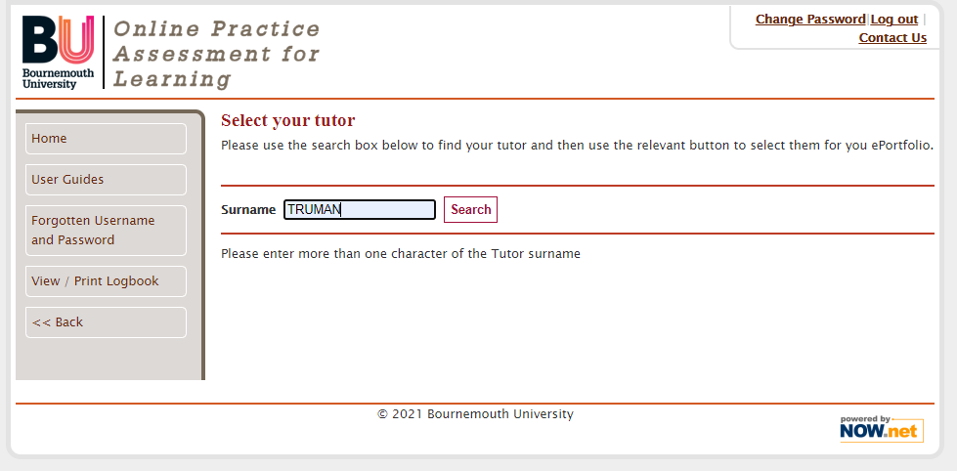
Put your academic advisor’s surname in the box and click search, some options will come up, select the appropriate one and click on the box labelled ‘select this tutor’.
Once you have done this, you will be taken to a front page, the active placement is labelled with an * normally it will work chronologically and BU0 will be highlighted however you will need BU1 . If there is a problem with this, please contact opalsupport@bournemouth.ac.uk .

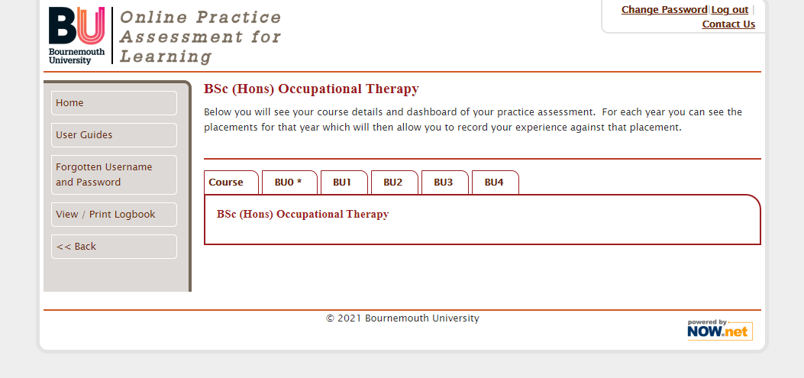
Click on the tab to activate the year and placement.
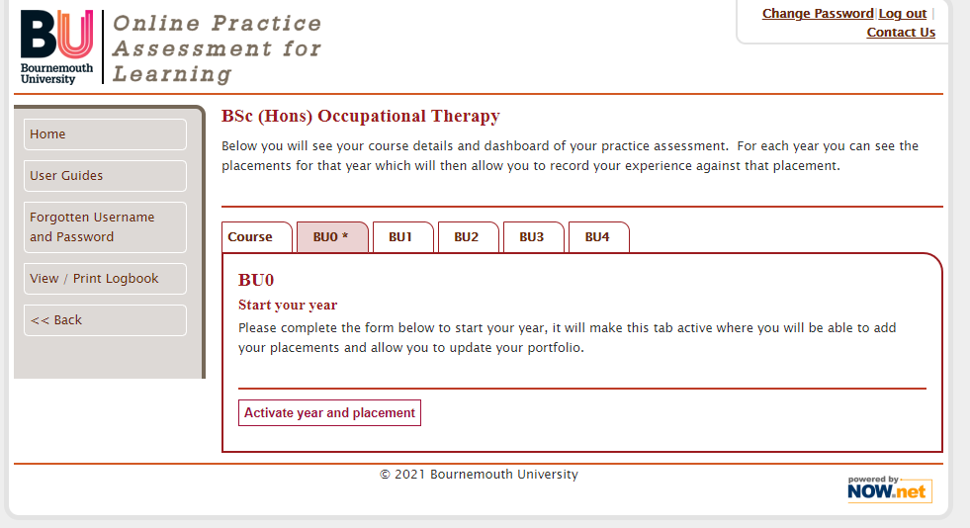

How to create a Placement
This is the first step you must undertake as a student prior to each placement commencing. When you have completed a placement or are going into a new placement for the first time OPAL gives you the opportunity to ‘Create placement’. By clicking on the create placement button it will open a section to enter details in about your placement.
The fields to be completed are relatively simple and can be completed with the information you receive from placements on the web (POW). These details and how to access them will be e mailed to you by the Placements Team.
You will be asked to enter the location of the placement, please include the placement area e.g. Anytown Hospital, and the ward / department/ service name. The start and finish dates are provided on POW and will be Monday starts and Sunday finishes. OPAL provides simple calendar boxes to click on and select dates (OPAL prefers you to use this function rather than typing in the dates yourself).

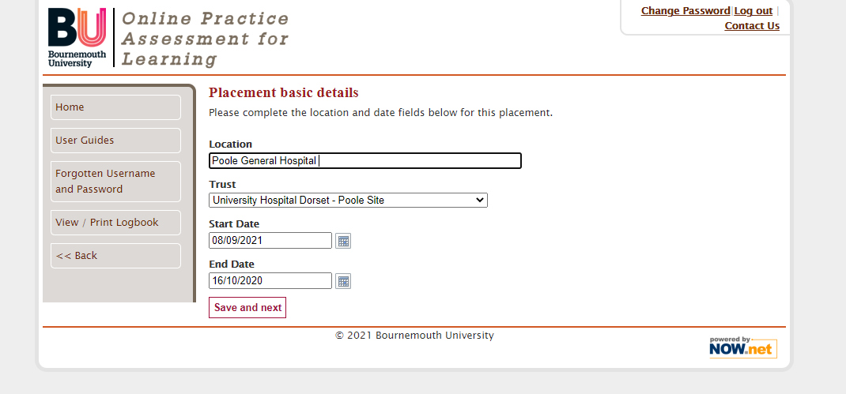
Click on ‘Save and Next’ and the system will automatically take you to the section for adding in your practice educator (referred to as mentor)

How to add in your Practice Educator
It is your responsibility to add your Practice Educator ( please note there are many names that are used interchangeably e.g. Practice Placement Educator, Placement Supervisor, Placement Assessor, mentor) . They will not be able to see the portfolio unless you do this. You should do this as soon as you receive your allocation. This step may take a little while to complete if you are unable to find their details in your initial search, so please start it as early as you can. Begin by typing in their surname. You may add more than one Practice Educator ( you will need this if you have more than one Practice Educator) , please add in additional ones and then click ‘finish’.

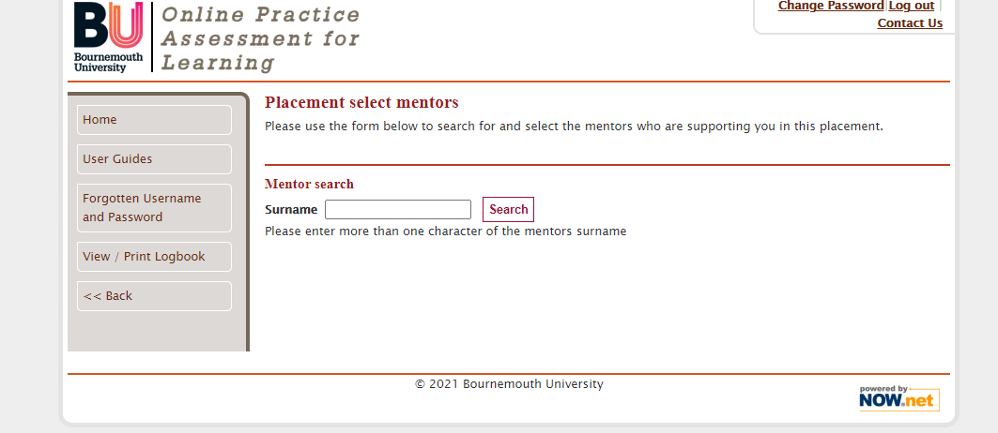
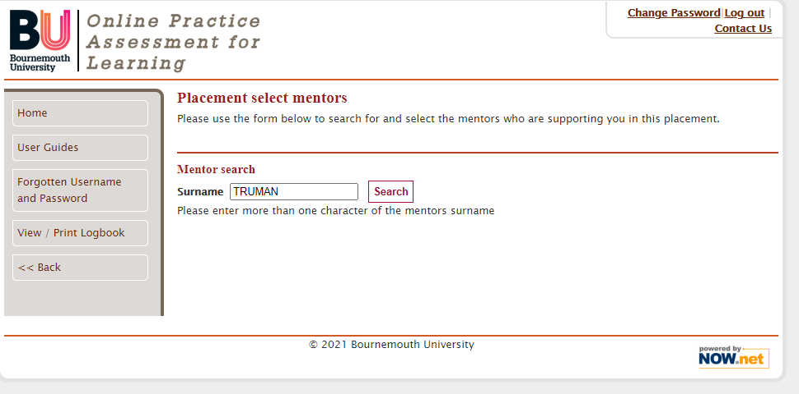
Once you have identified it is the correct Practice Educator click on ‘select this mentor.’
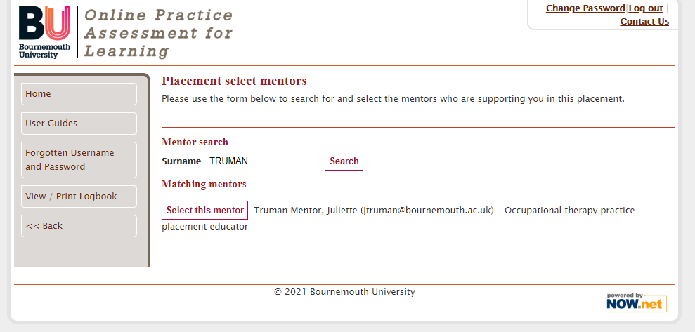

If the system cannot locate your Practice Educator there may be some reasons for this, stop and check with your Practice Educator:
1. Are they registered with OPAL; this is the Practice Educators responsibility. If they are not, they can gain advice and support in the following ways:

OPAL System | www.opalbu.com | User guides/ occupational therapy /
Placement Website | BU Placement Information | Useful info and forms / OPAL User Guides
Virtual placement resources | Link available through allocation letter | This links your Practice Educator to narrated resources.

2. Has your Practice Educator changed their name – this is a common challenge when staff register in one name and then subsequently change their name. Ask your Practice Educator for the name in which they registered.
3. Check the spelling of the name.

The Dashboard
After completing the initial information and clicking finish, you should now see something we refer to as the Dashboard. This is the main page and from where you will do all your navigation (please note that this is displayed below in two pictures). Please take a look at the different sections and familiarise yourself with the dashboard. Please note that your Practice Educator and AA will also have a version of the Dashboard – they layout is the same, but the functionality differs for each role. Hence you will be able to edit some aspects and your Practice Educator will have no permissions to do this.
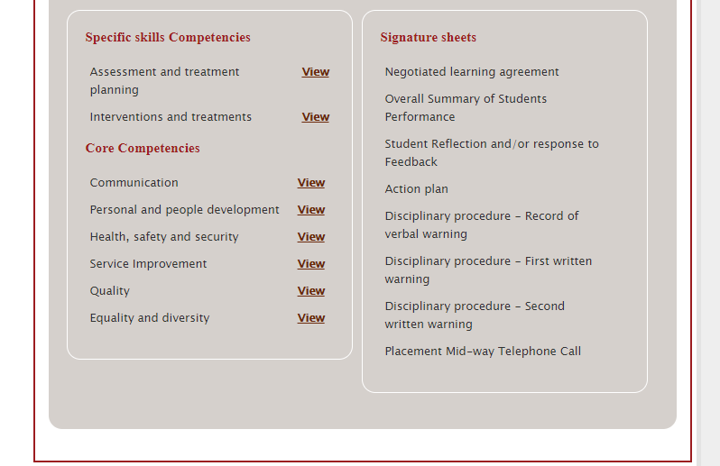
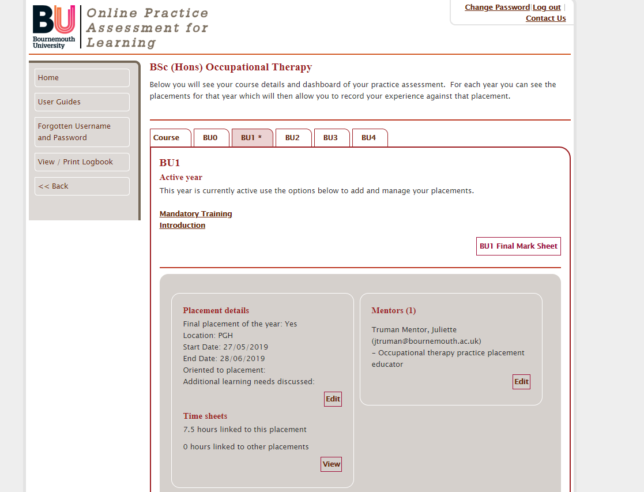
Indicates the active placement.
Complete this record of mandatory training.
Important end of placement sign off
Basic placement details that you can edit at any time.
Time sheets that you will edit daily/ weekly.
Useful resources
Assessment section
Core Interactive documents

Adding in your Mandatory Training
From the dashboard locate the hyperlink for mandatory training (top box). Click on the boxes to indicate what training you have completed. Although the University keeps records it is important that your Practice Educator can see the training you have undertaken. Click the back button to return to the main dashboard.
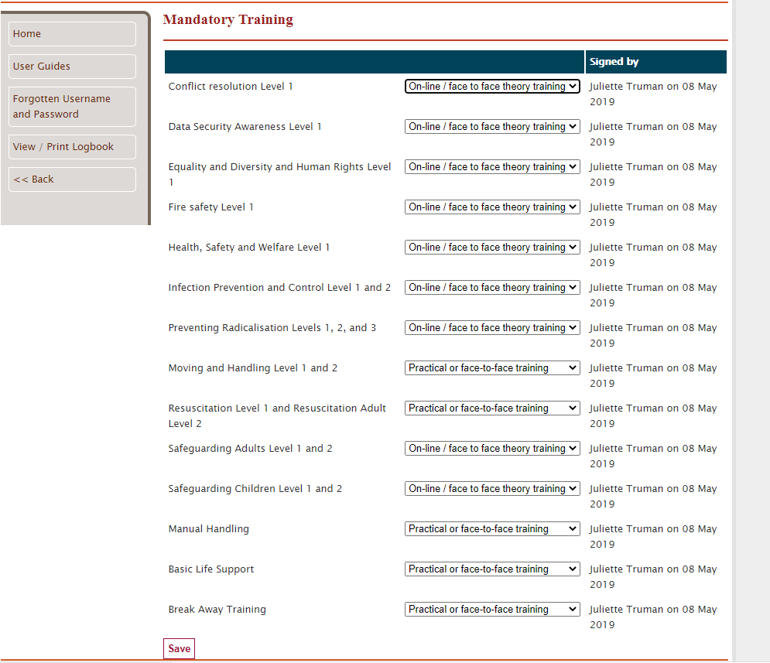

Changing Placement Details
After a placement has been set up there may well be reasons that you need to change some of the details. This can only be done by you. From the dashboard you will see an ‘edit’ button (arrow below) in the placement details box. By clicking on this button, the placement details are opened and can be changed. If you need to change your Practice Educator, click on the edit button in the Practice Assessor/Supervisor box on the dashboard and this will open a page in which you can add new people or remove people.

OPAL Support
We recognise that new systems can be challenging to navigate and understand. Please use the following resources to support you with OPAL.
Resource | Contact details | What they can assist with
Opal Support | opalsupport@bournemouth.ac.uk | - Forgotten passwords / username  • Unlocking portfolios  • Practice Educator Access
OPAL Guides | www.opalbu.com | - Guidance for students and Practice Educators
Programme Specific Guides |  | - Narrated PowerPoint  - Guides
Placement on the web (POW) queries | hssplacements@bournemouth.ac.uk | - Queries relating to information on the POW system (placement details and contacts)

